Maven Lab 2

1. Operators

CODE:SUM

module sum(input [3:0]a,input [3:0]b,output [3:0]result);

assign result=a+b;

endmodule

NETLIST:

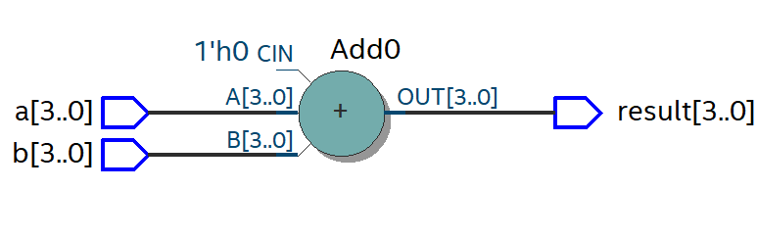

CODE: SUBTRACTOR

module sub(input [3:0]a,input [3:0]b,output [3:0]result);

assign result=a-b;

endmodule

NETLIST:

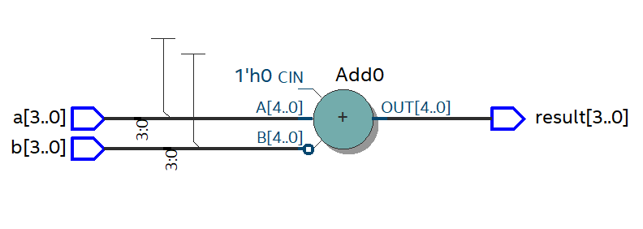

CODE: MULTIPLICATION

module mul(input [3:0]a,input [3:0]b,output [3:0]result);

assign result=a*b;

endmodule

NETLIST:

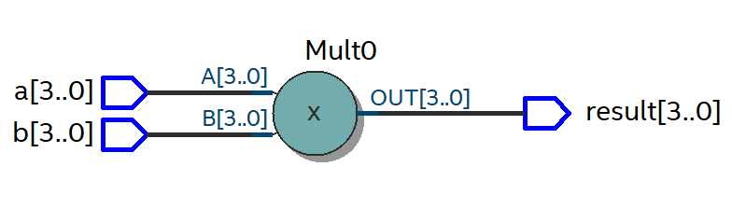

CODE: DIVISION

module div(input [3:0]a,input [3:0]b,output [3:0]result);

assign result=a/b;

endmodule

NETLIST:

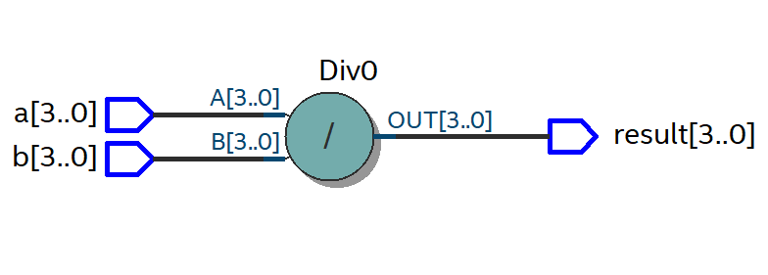

CODE: AND

module and_gate(input a,input b,output result);

assign result=a&b;

endmodule

NETLIST:

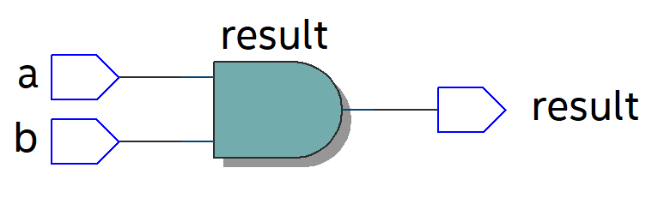

CODE: OR

module or_gate(input a,input b,output result);

assign result=a|b;

endmodule

NETLIST:

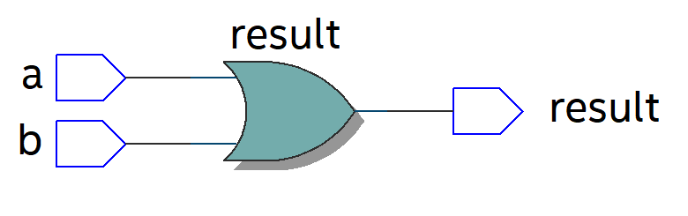

CODE: XOR

module xor_gate(input a,input b,output result);

assign result=a^b;

endmodule

NETLIST:

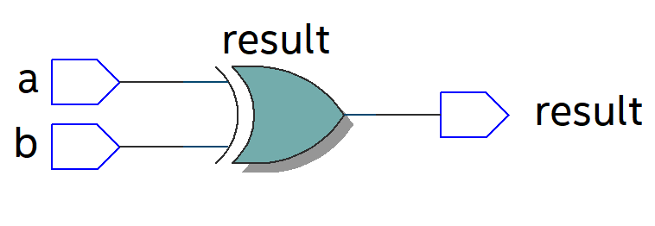

CODE: EQUAL

module equal_op(input a,input b,output result);

assign result=(a==b);

endmodule

NETLIST:

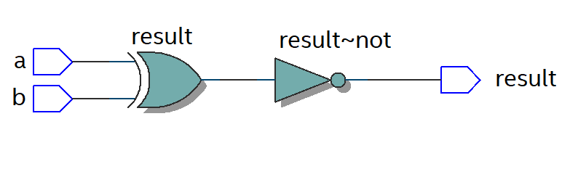

CODE: EQUAL

module equal_op(input a,input b,output result);

assign result=(a==b);

endmodule

NETLIST:

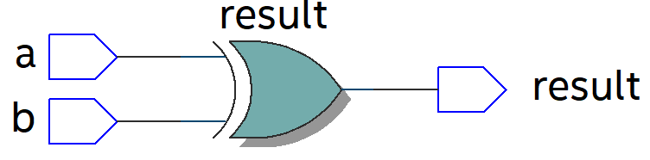

CODE:LEFT SHIFT

module Left_Shift ( input [3:0] data, output [7:0] result);

assign result = data << 2;

endmodule

NETLIST:

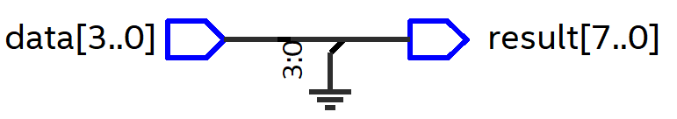

CODE:RIGHT SHIFT

module Right_Shift ( input [3:0] data, output [7:0] result);

assign result = data >> 2;

endmodule

NETLIST:

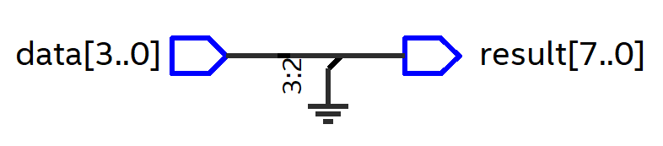

CODE:CONDITION OPERATOR

module Conditional_Op( input condition,input true_result,input false_result,output result);

assign result = (condition) ? true_result : false_result;

endmodule

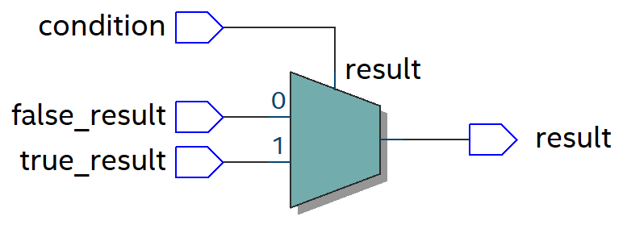

1. ALU

CODE:

module ALU(input [7:0]a,input [7:0]b,input [2:0]opcode,input clk,input rst,output reg [7:0]result);

always@(posedge clk)

begin

if(rst)

begin

result=8'b0;

end

else

begin

case(opcode)

3'b000: result<=a+b;

3'b001: result<=a-b;

3'b010: result<=a*b;

3'b011: result<=a/b;

3'b100: result<=a&b;

3'b101: result<=a|b;

3'b110: result<=a^b;

3'b111: result<=(a>b)?8'b1:8'b0;

endcase

end

end

endmodule

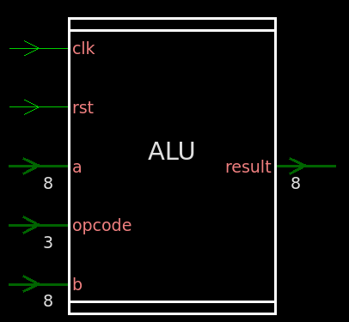

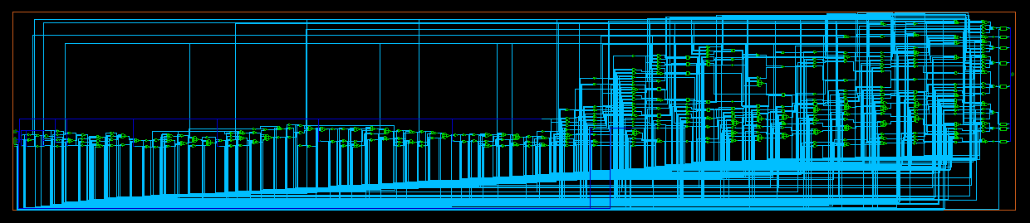

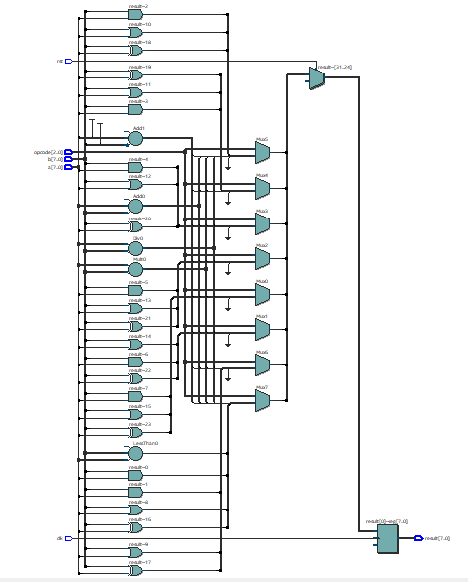

TESTBENCH:

module ALU_tb;

reg [7:0]a;

reg [7:0]b;

reg [2:0]opcode;

reg clk,rst;

wire [7:0]result;

integer i;

ALU dut(a,b,opcode,clk,rst,result);

initial

begin

a=8'b01100011;

b=8'b00011001;

clk=0;

rst=0;

opcode=8'b0;

end

always

begin

#5 clk=~clk;

end

initial

begin

rst=1;

#10 rst=0;

for(i=0;i<8;i=i+1)

begin

opcode = i;

#10;

end

end

endmodule

